React Hooks
Hooks allow function to have access to state and other react features without using classes.
They provide a more direct API to react concepts like props,state,context,refs and lifecycle.
Hooks are a functions that let you “hook into” React state and lifecycle features from functional components.
State hooks like useState and useReducer enable functional components to manage state in a clean, efficient, and modular way.

Example1:-
- Favorite color slection is
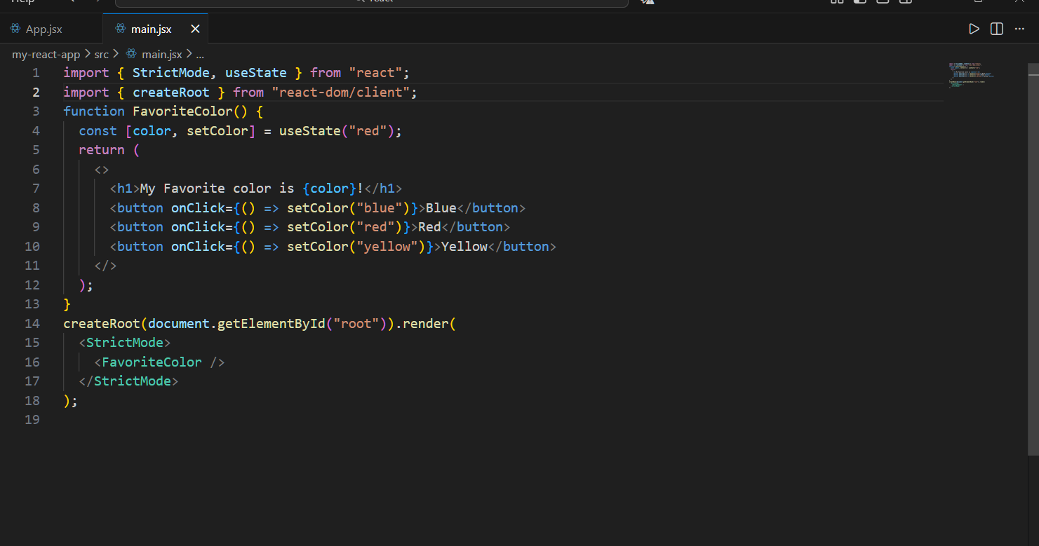

Output

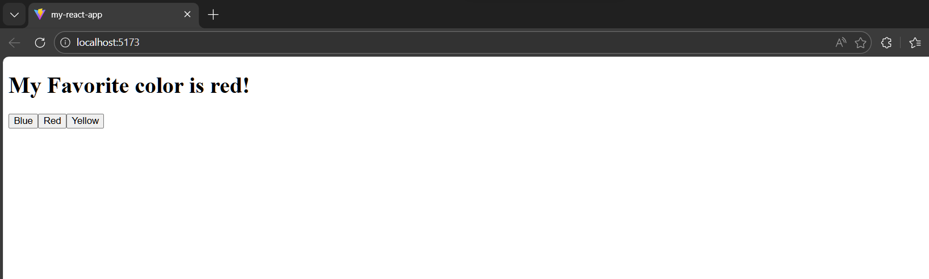

Example2:-Count Down
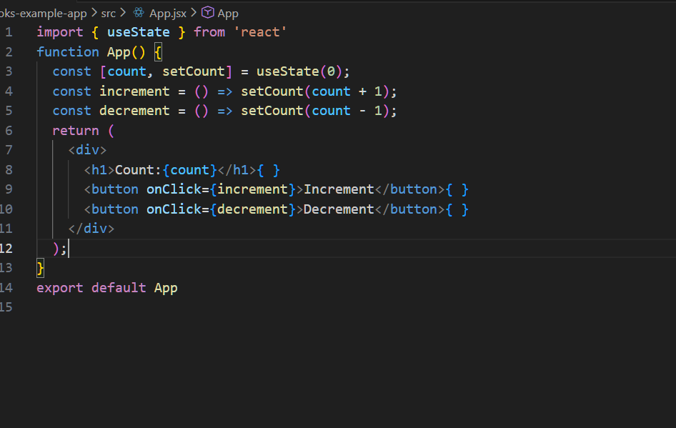

Output

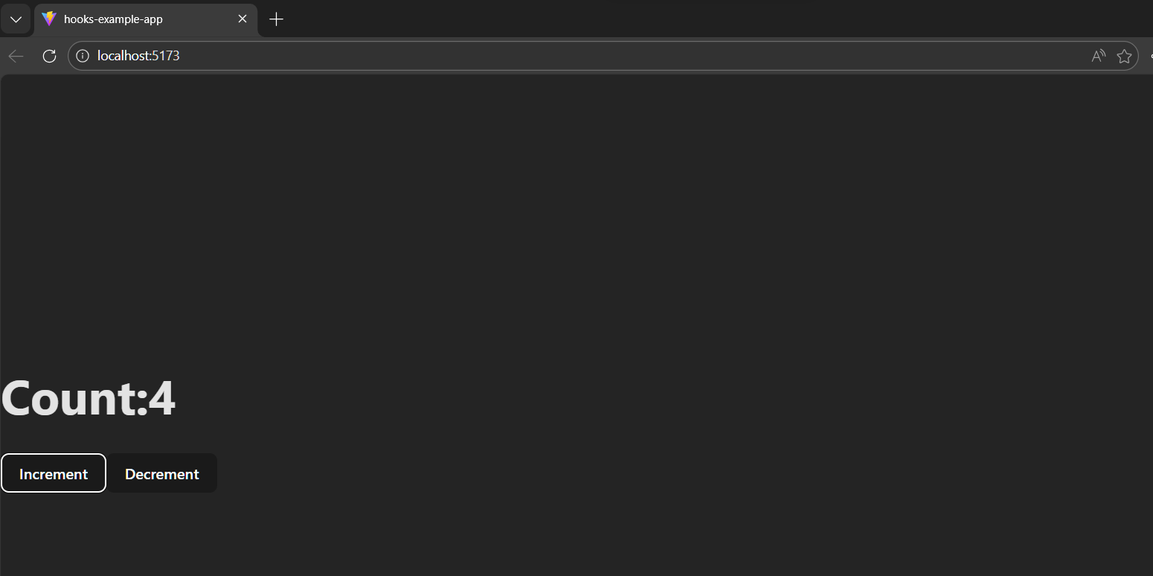
useState:
The useState hook is used to declare state variables in functional components. It allows us to read and update the state within the component.
React useState Hook allows us to track state in a function component.
State generally refers to data or properties that need to be tracking in an application.
Import useState:
To use the useState Hook,we first need to import it into our component.
Example:- import{useState} from “react”;
Initialize useState:-
- We initialize our state by calling useState in our function component.
- UseState accepts an intial state and return two values.
* The current state
*A function that updates the state.

example:
-Initialize state by at the top of the function component.
Import{useState} from “react”;
function favoriteColor()
{
Const[color,setColor]=useState(“red);
}
* The first value, color is our current state.
*The second value, setColor is the function that is used to update our state.

